TECHFRNDS
Industry-Ready Training & Paid Internship Program
📌 DSA (2 Months) + MERN Stack (3 Months) + Paid Internship (2 Months)
🤖 AI Integration using OpenAI & Gemini APIs

🎯 Program Highlights
✔ Structured 5-Month Roadmap
✔ Beginner → Advanced Level Training
✔ DSA + Full Stack + AI Integration
✔ Live Projects & Case Studies
✔ 100% Paid Internship Guarantee
✔ Stipend: ₹5,000 – ₹15,000
✔ Certificate + Internship Letter + Offer Letter
✔ Placement & Interview Guidance
✔ Career Cost : 30000rs(Limited Offer)

🧠 PHASE 1: DATA STRUCTURES & ALGORITHMS (2 Months)
📅 Month 1 – DSA Foundations
Week 1
- Programming Basics (C++ / Java / Python – logic focused)
- Time & Space Complexity (Big-O, Big-Ω, Big-Θ)
- Problem-solving mindset
Week 2
- Arrays (1D & 2D)
- Prefix Sum
- Sliding Window Technique
- Practice: 15–20 Problems
Week 3
- Strings
- Hashing (Maps & Sets)
- Two Pointer Technique
- Real interview-based questions
Week 4
- Recursion
- Backtracking
- Basic Sorting Algorithms
  - Bubble Sort
  - Selection Sort
  - Insertion Sort

📅 Month 2 – Advanced DSA
Week 5
- Searching Algorithms
  - Binary Search
  - Variations of Binary Search
- Sorting Algorithms
  - Merge Sort
  - Quick Sort
Week 6
- Linked List (Singly & Doubly)
- Stack
- Queue
- Applications in real problems

Week 7
- Trees
  - Binary Tree
  - Binary Search Tree
- Tree Traversals
- Height, Diameter, LCA
Week 8
- Graphs
  - BFS & DFS
  - Shortest Path Concepts
- Greedy Algorithms
- Final DSA Mock Tests
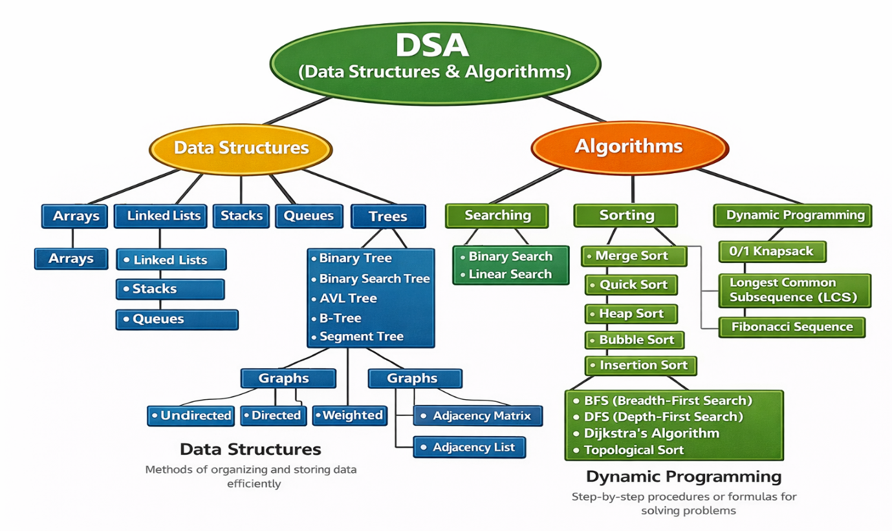

💻 PHASE 2: MERN STACK DEVELOPMENT (3 Months)

📅 Month 3 – Frontend Development (JS = 2 Weeks)
Week 9 – Web Foundations
- HTML5 (Semantic & SEO-friendly)
- CSS3 (Flexbox, Grid)
- Responsive Design
- UI Best Practices
Week 10 – JavaScript (Core JS)
- JavaScript Fundamentals
- Variables & Data Types
- Functions & Scope
- Conditional Statements & Loops
- DOM Manipulation (Part-1)

Week 11 – JavaScript (Advanced JS)
- DOM Manipulation (Part-2)
- Events
- ES6+ Features
- Async JS (Callbacks, Promises, Async/Await)
- Mini JavaScript Projects
Week 12 – React.js Basics
- React.js Introduction
- Components
- Props & State
- JSX
- Basic React App
📅 Month 4 – Advanced Frontend + Backend
Week 13 – Advanced React
- React Hooks
- Routing
- API Integration
- Frontend Project
Week 14 – Node.js
- Node.js Fundamentals
- NPM
- Event Loop
- Backend Basics
Week 15 – Express & MongoDB
- Express.js
- REST APIs
- Middleware
- MongoDB
- Mongoose
- CRUD Operations
Week 16 – Authentication & Security
- Authentication & Authorization
- JWT
- Role-based Access
- Backend Project

📅 Month 5 – MERN + AI Integration (Reduced & Focused)
🤖 AI Integration (Using OpenAI & Gemini APIs)
Week 17 – AI API Foundations
- Introduction to AI APIs
- OpenAI API Basics
- Gemini API Basics
- API Keys & Security
Week 18 – AI Features in MERN Apps
- AI-powered Chatbot using OpenAI
- Prompt Engineering (Basics)
- Context Handling
- AI APIs inside MERN Backend
Week 19 – Practical AI Use-Cases
- Gemini API for:
  - Smart Suggestions
  - Content Generation
  - Automation Features
- Real-world AI feature integration

Week 20 – Capstone Project
- MERN App + AI Integration
- Resume-worthy Industry Project
- Basic Deployment
- Demo Day

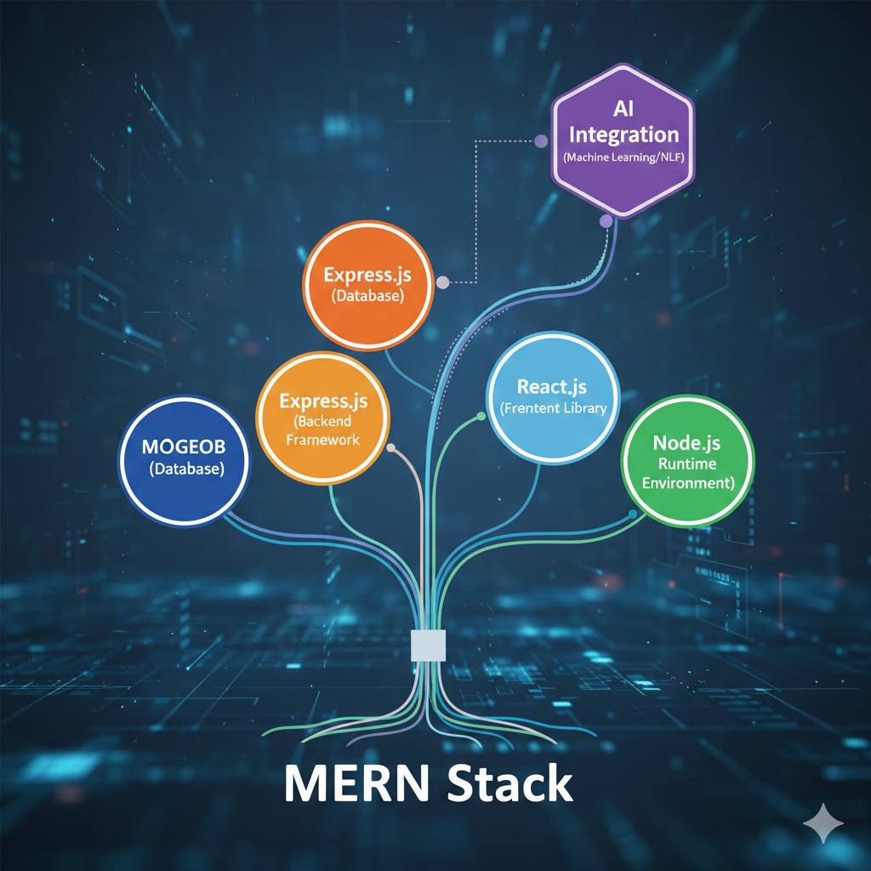

💼 PAID INTERNSHIP (Guaranteed)
📌 Duration: 2 Months
📌 Stipend: ₹5,000 – ₹15,000
📌 Mode: Work from Home / Hybrid
Roles:
- MERN Developer
- AI-Integrated Web App Developer
👉 Real projects, real experience — no dummy tasks

📜 Certifications You’ll Get
✔ Techfrnds Training Certificate
✔ Paid Internship Certificate
✔ Project Completion Certificate

🎓 Who Can Join?
- B.Tech / BCA / MCA Students
- Beginners & Intermediate Coders
- Anyone serious about Software Development & AI

⏳ Limited Seats
⚠ Limited seats per batch
⚠ Early enrollment = priority internship allocation
⚠ Miss this batch = wait for next cycle

📞 Call to Action
💬 Don’t just learn coding — build your career with Techfrnds.
📲 Enroll Now
📍 Batch Starts: XXX
💰 Career Cost: ₹30,000 (Limited-Time Offer)

